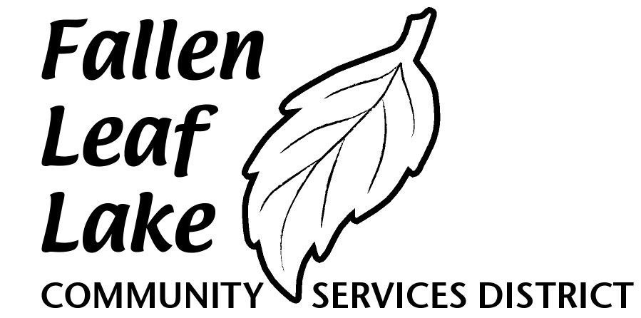
Post Office Box 9415
South Lake Tahoe, CA 96158

AGENDA
FALLEN LEAF LAKE COMMUNITY SERVICES DISTRICT
May 18, 2020
Held under Executive Order N-29-20
Teleconference
01:00 PM
Join Zoom Meeting
https://us02web.zoom.us/j/86766218743
Meeting ID: 867 6621 8743
Dial by your location
+1 669 900 6833 US
Meeting ID: 867 6621 8743

Robert J. Cathcart, President Grant Calof, Director
Mike Casey, Vice-President Stephen A. Malley, Director
Bruce Hart, Director

Call to Order

Roll Call

New Business

- Discussion and Possible Motion(s) regarding COVID-19/CLM Store and Marina Operations – President Cathcart
- Adjourn

In compliance with the Americans with Disability Act, if you need special assistance to participate in this meeting, please contact CSD General Manager Gary Gerren on ggerren@fllcsd.org or 530.544.3300. Notification 48 hours prior to the meeting will assist the District in making reasonable accommodations to ensure access to the meeting.
(28 CFR 35.102-35.104 ADA title II)

